**Practice problems - Semester 2 CAPE1310**

**Reaction Engineering**

1. The pyrolysis of ethane is performed at a temperature of 500 °C and the activation energy for the reaction is found to be 75000 cal/mol. Assuming the same activation energy also holds at 650 °C, how faster would be the reaction be at 650 °C compared to 500 °C? (Use R = 1.987 cal/mol.K)

*Answer: At 650 °C, the pyrolysis reaction would be faster by a factor of approximately 2838*

2. At 25°C, the rate constant for the reaction of ethyl acetate (CH3COOC2H5) by NaOH is 6.5 (L/mol.min). When the reaction is performed in a batch reactor with a starting concentration of each reactant as 0.03 M, what proportion of the ethyl acetate ester would be reacted after 10 minutes?

*Answer: 66.1%*

3. The decomposition reaction of a reactant species is being studied in the lab in a constant volume batch reactor. When using an initial concentration of the reactant of 1M, the conversion of the reactant is 80% after 8 minutes and 90% after 18 minutes. Can you formulate the rate expression to describe this reaction?

*Answer: 0.5 (l/mol.min) CA2*

4. The decomposition reaction of a liquid reactant A is known to follow first order kinetics. When the reaction is carried out at 60 °C in a batch reactor, we find 70% of A being converted in 13 minutes.

(a) What is the value of the rate constant for the reaction?

*Answer: 0.0926 (min)-1*

(b) If the same reaction were to be carried out using the same initial concentration of A at a lower temperature of 40 °C, would the rate constant of the reaction be the same or different?

(c) If the same reaction were to be carried out in a CSTR, what would the order of the reaction be?

(d) Find the space time of the CSTR required to achieve the same reaction conversion of 70% at 60 °C?

*Answer: 25.2 min*

(e) If the same reaction was carried out in a 26 litre PFR with a volumetric flow rate of the reactant equal to 2 litre per minute at 60 °C, what conversion of the reactant would be reached at the end of the PFR?

*Answer: 70%*

**Biochemical Engineering**

5. A microorganism is growing at its maximum possible specific growth rate in an environment with an abundance of substrate concentration. The growth of the biomass over the first four days is documented below:

|  |  |  |  |  |  |
| --- | --- | --- | --- | --- | --- |
| Time (days) | 0 | 1 | 2 | 3 | 4 |
| Biomass (mg/L) | 50 | 75 | 111 | 166 | 248 |

(i) Calculate rg.m

(ii) What will the biomass concentration be after a period of 10 days if the microbe continues to grow at the maximum specific growth rate?

*Answer: (i) 0.4 day-1 (ii) 2730 mg/L*

6. For an enzymatic reaction that follows the Michaelis-Menten kinetic model, what is the percentage increase in the rate of formation of the product when the substrate concentration is changed from 0.33*Km to 0.5*Km? (where Km stands for the Michaelis-Menten constant)

*Answer: 33%*

7. Shown below are kinetics data for an enzyme that was collected in both presence and absence of an inhibitor. The enzyme concentration used in both experiments was 1.5 µM. vo is the rate of product formation in the enzyme-catalysed reaction and [S] is the substrate concentration.

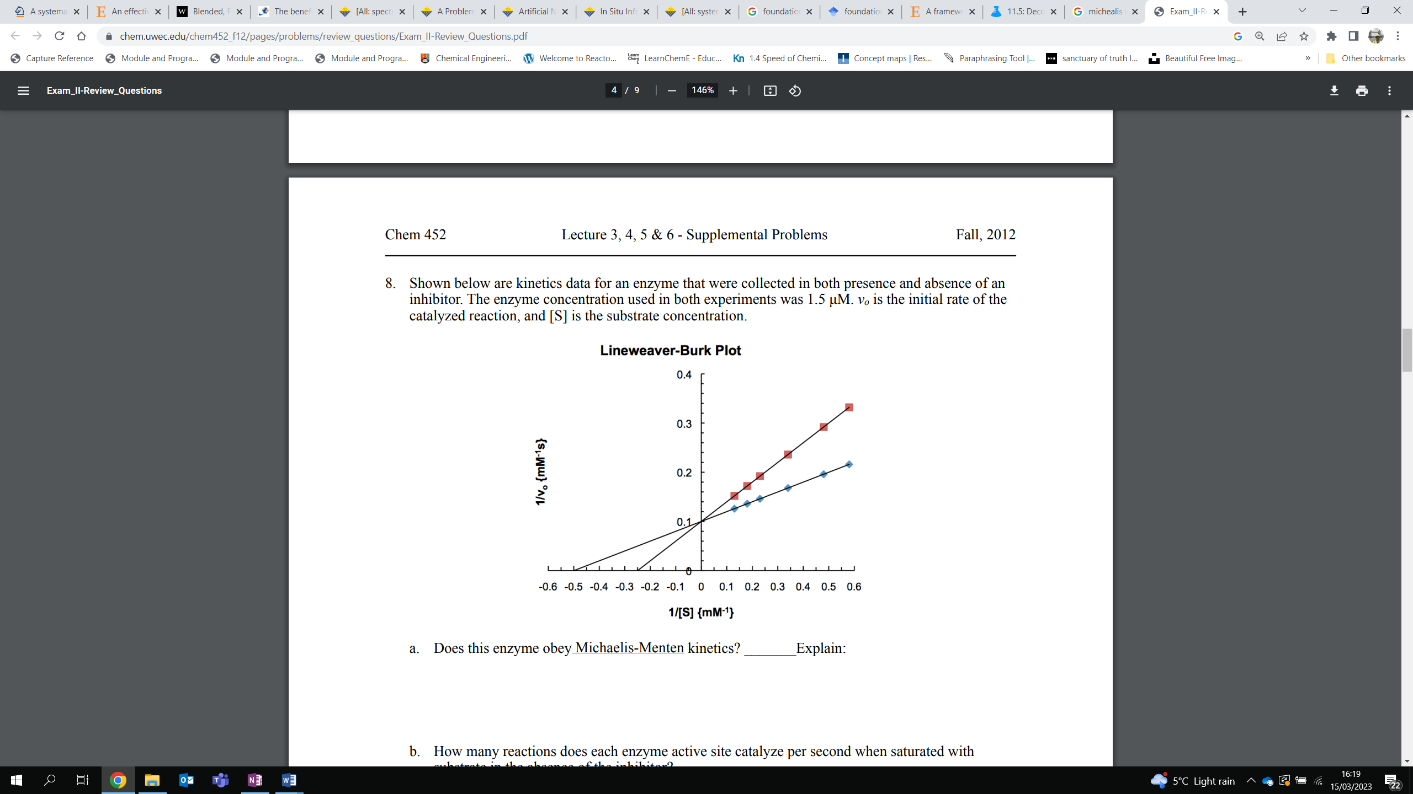

(a) What type of inhibition is depicted in the double reciprocal plot shown above? Explain why.

(b) Which of the two curves (red squares or blue diamonds) depict the inhibited enzymatic reaction? Explain why.

(c) Explain the inhibition phenomenon by drawing an appropriate reaction scheme (use E, S, P and I to denote the enzyme, substrate, product and inhibitor respectively)

(d) What is the maximum rate of reaction in (i) the absence of the inhibitor and (ii) the presence of the inhibitor?

*Answer: 10 mM/s in both cases*

(e) What is the value of the Michaelis-Menten constant in (i) the absence of the inhibitor and (ii) the presence of the inhibitor i.e. the apparent Michaelis-Menten constant?

*Answer: (i) 2 mM (ii) 4 mM*

(f) What is the value of *KI* if the concentration of the inhibitor in the enzyme-inhibited reaction is 0.5 mM?

*Answer: 0.5 mM*

(g) The biochemical engineers working on this process later identify the presence of a second inhibitor species in the reaction system which also binds to the enzyme the same way as the first inhibitor species. The engineers also identify that the *KI* value for this second inhibitor species is much larger compared to *KM* (*KI* >>> *KM*). How would this affect the inhibited kinetics curve shown on the above plot (i.e. how will the slope and y-intercept change?)